**Be Safe & Sure**

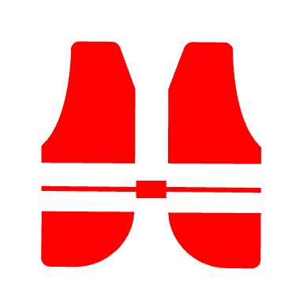

Fit a mast head buoyancy float to prevent an inversion

Check the weather

Wear the right clothing – staying warm even when wet is a confidence boost

Take an alternative means of propulsion – a paddle

Make sure the bungs are in & buoyancy bags/tanks are watertight

Tell someone ashore your plans



*Wave your arms up and down*

Know how to call for help *Whistle or shout*

*Use a mobile or radio*

Always keep a look out – avoid a collision (learn the rules)

